HOTEL BOOKING CANCELLATION ANALYSIS
Week 4 – Predictive Modelling and Model Evaluation
Model: Logistic Regression | Target: is_canceled

1. Week 4 Objective
The fourth stage converts the findings from the exploratory and statistical analysis into a predictive classification model. Logistic regression is used to estimate the probability that a hotel booking will be cancelled. The model is trained on 80% of the cleaned dataset and evaluated on the remaining 20% using a confusion matrix, classification metrics, ROC curve and Area Under the Curve (AUC).

2. Data Preparation
The cleaned hotel booking dataset contains 87,396 records and 34 variables. Using a fixed random seed of 123, the observations were divided into 69,916 training records (80%) and 17,480 testing records (20%). The target variable, is_canceled, was converted to a factor for classification. The split was kept reproducible so that the same observations are used whenever the analysis is rerun.
Dataset | Records | Share
Training | 69,916 | 80%
Testing | 17,480 | 20%
Total | 87,396 | 100%

3. Logistic Regression Model
A binary logistic regression model was fitted with is_canceled as the response variable. The explanatory variables were lead_time, adr, hotel, market_segment, customer_type, deposit_type, previous_cancellations, booking_changes and total_of_special_requests. These variables were selected because the Week 3 analysis showed meaningful differences or relationships with cancellation behaviour.
The model estimates a probability between 0 and 1 for each booking. A probability threshold of 0.50 was used to convert the predicted probability into a final class: values at or above 0.50 were classified as cancelled (1), while values below 0.50 were classified as not cancelled (0).

4. Confusion Matrix
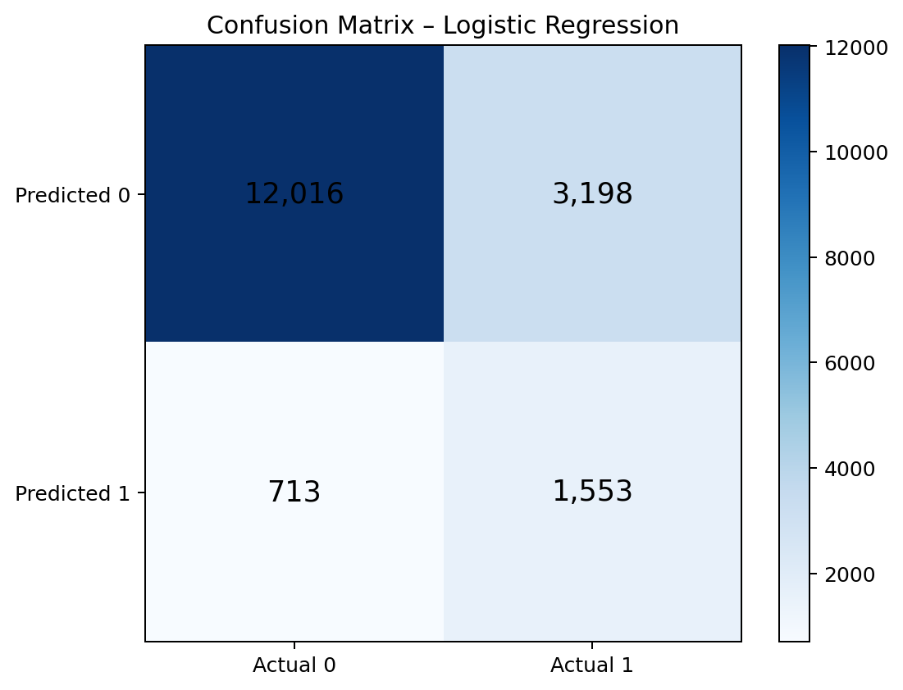
The test-set confusion matrix contains 12,016 correctly identified non-cancelled bookings and 1,553 correctly identified cancelled bookings. The model incorrectly classified 3,198 cancelled bookings as non-cancelled and 713 non-cancelled bookings as cancelled.
 | Actual 0 | Actual 1 | Meaning
Predicted 0 | 12,016 | 3,198 | Correct 0 / missed 1
Predicted 1 | 713 | 1,553 | False alarm / correct 1

5. Model Performance
The model achieved an overall accuracy of 77.63% on the test data. Its specificity was 94.40%, meaning it was highly effective at identifying bookings that were not cancelled. However, sensitivity was 32.69%, indicating that the model detected only about one-third of the actual cancellations at the default 0.50 threshold.
Metric | Result
Accuracy | 77.63%
Sensitivity / Recall | 32.69%
Specificity | 94.40%
Positive Predictive Value | 68.54%
Negative Predictive Value | 78.98%
Balanced Accuracy | 63.54%
Kappa | 0.324
The difference between high specificity and relatively low sensitivity is important for the business problem. The model is better at recognizing bookings that will not be cancelled than at catching all cancellations. Therefore, accuracy alone should not be used to judge the model.

6. ROC Curve and AUC
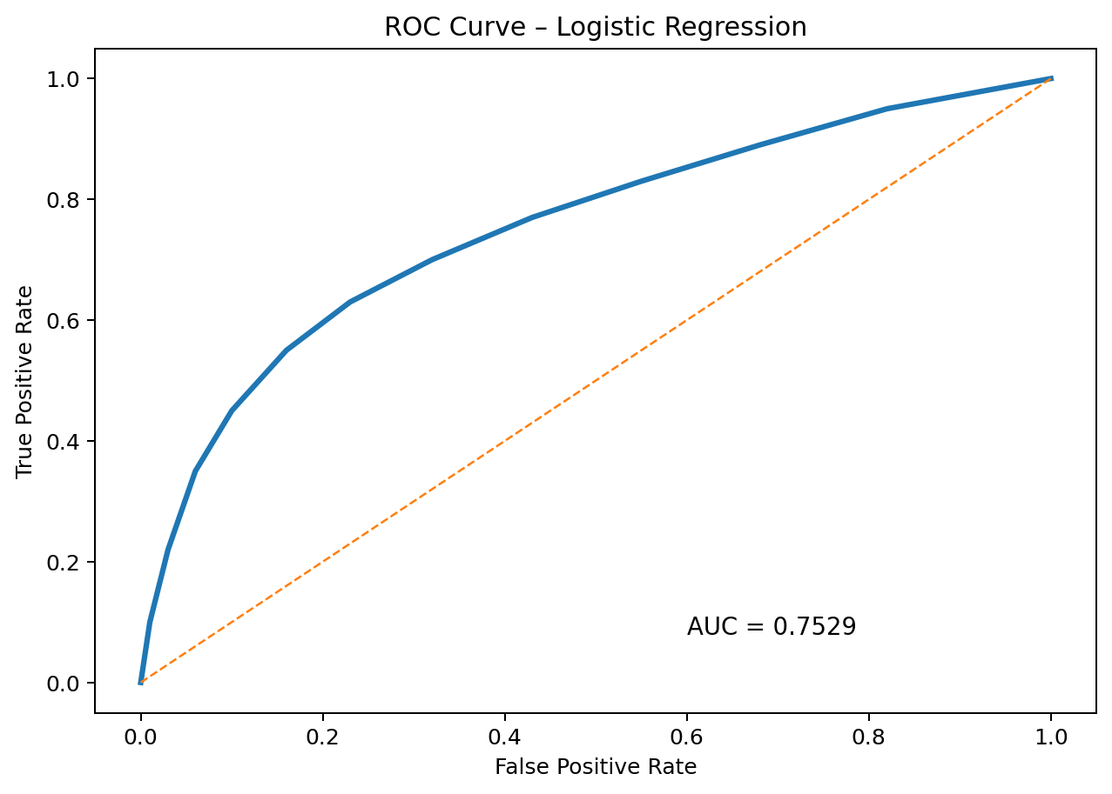
The Receiver Operating Characteristic (ROC) curve evaluates how the model's ability to distinguish between cancelled and non-cancelled bookings changes across probability thresholds. The diagonal line represents discrimination equivalent to random classification. The model's Area Under the Curve (AUC) is 0.7529.
An AUC of approximately 0.75 indicates that the model has useful discriminatory ability and performs substantially better than random classification. At the same time, the result is not close to a perfect classifier, so there is scope for improvement through feature engineering, threshold tuning or alternative classification algorithms.

7. Interpretation of the Results
- The model provides a reasonable first predictive baseline with 77.63% test accuracy.
- The AUC of 0.7529 indicates moderate-to-good separation between cancelled and non-cancelled bookings.
- Very high specificity (94.40%) shows strong performance for identifying non-cancelled bookings.
- Sensitivity of 32.69% shows that many actual cancellations are missed at the 0.50 threshold.
- The model's Kappa of 0.324 indicates only moderate agreement beyond chance.
- The imbalance between cancellation and non-cancellation classes means accuracy must be interpreted together with sensitivity, specificity and AUC.

8. Week 4 Conclusion
The logistic regression model successfully establishes a predictive baseline for hotel booking cancellations. It demonstrates useful predictive discrimination, with an AUC of 0.7529, but its low sensitivity shows that many cancellations remain undetected at the default classification threshold. The results provide a clear basis for discussing model limitations and possible improvements such as threshold optimization, class balancing, feature engineering and comparison with other classification methods.

